**NBA PLAYERS REPORT**

**1.1** This Report consist of 20 NBA Players showing the Total Average Points, Assists Rebounds etc….

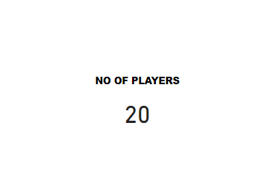

**1.2** This Report below is showing the Career Average Point scored by each Player, Micheal Jordan and Will Chamberlin appeared to have made the highest Point so far with 30.1pt and Bill recorded the lowest Point with a total of 15.1 on average

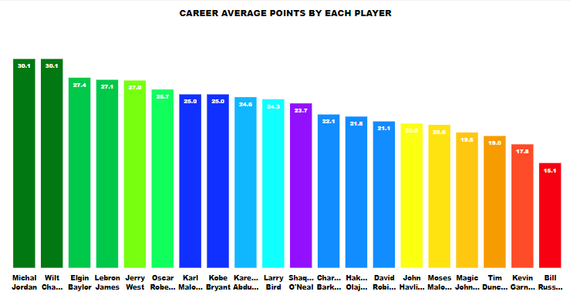

**1.3** This Report below is showing the Career Average Assist Made by each Player in which Magic Johnson and Moses Malone appears to have made the highest career average assist in the NBA, it is safe to say they are one Magic Johnson and Moses Malone is the Best Creative Point Guard & Power Forward in the League. Shaquille O’Neal have the lowest Average assist in the league with 2.50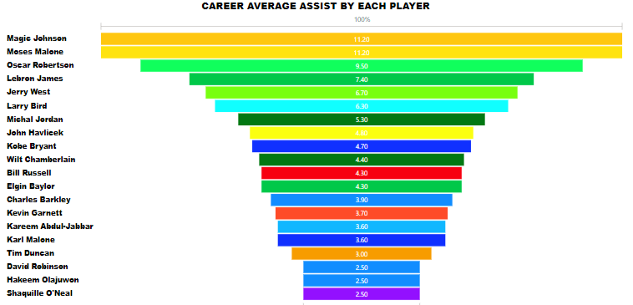

**1.4** This Report below is showing the Career Average Rebounds Made by each Player in which wilt chamberlain recorded the highest rebounds in the league with a total average of 22.90, this show that Chamberlain is good in the air both in the defence and offence whole Kobe Bryant recorded the lowest in the league

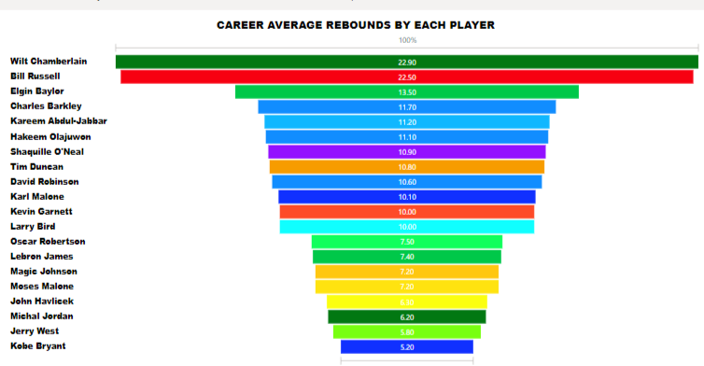

**1.5** The image Below is showing the number of time each player have featured in the NBA all star Games, Kareem Abdul-Jabbar have featured in a total of 19 times while Kobe Bryant is next to him with 18 times as well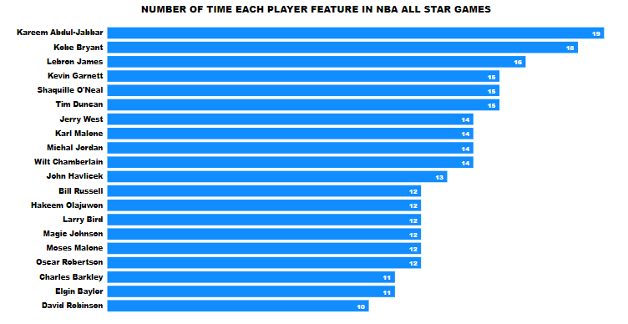

**1.6** Thisreport is showing the MVP Awards won by each player in which Karreem Abdul-Jabber can boost of six (6) MVP Awards which is the highest while John Havlicek recorded the lowest MVP Award won in this Data

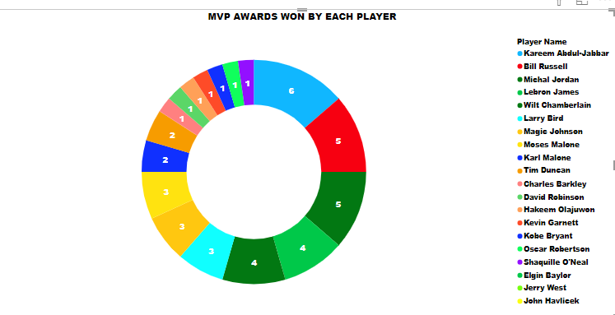

**1.7** This image below gives a report of the Championship won by each Player; Bill Russell recorded the highest number of championship won **(11)**

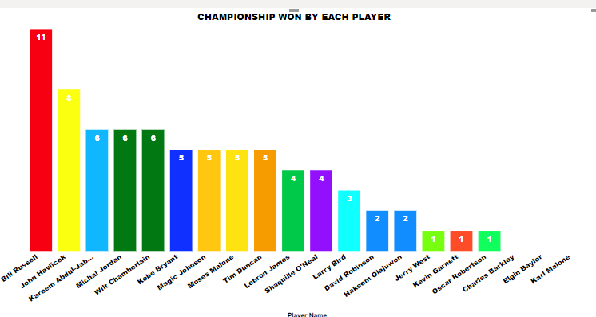

**1.7** The Chart Below illustrate the number of times each player has appeared in the NBA First team, NBA Second Team and NBA Third Team. 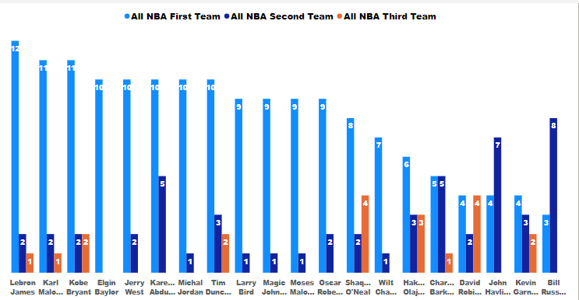

**1.8** The Report and Analysis Given here are Based on the Data Available at a time. Thanks